Estimate of the volume of magma emitted during the fourth episode

G.Wadge (28 August 2009)

Purpose

Though less well-defined, shorter and less voluminous than the previous three episodes, the period between 28 July 2008 and 3 January 2009 involved the eruption of new magma from Soufriere Hills Volcano. During this period MVO did not have a staff scientist dedicated to volume estimation and so there was no contemporary estimate of erupted volume from a single source. In the course of compiling an overview of lava production across the whole eruption to date (Wadge et al., in prep.), an estimate has been made of the volumetric output during this fourth episode. This note provides an explanation of these estimates, and recent and future fieldwork and survey may provide data to improve them.

The Fourth Episode

This comprised two parts: (1) a pumice-bearing Vulcanian explosion on 28 July 2008 followed in early August by very weak lava extrusion, probably ending that month, and (2) a vigorous period of lava extrusion from 10 December 2008 to 3 January 2009 after a non-pumiceous Vulcanian explosion on 2 December 2008. The episode ended with two more pumice-bearing explosions on 3 January 2009.

The vent for (1) initiated at the Gage’s Wall vent on the west side of the dome above the Gage’s valley, and expanded upslope as a result of the explosion. Similarly (2) began in this expanded vent, but extended further up into the dome such that by late December the lava vent was high and central enough to enable pyroclastic flows to travel to the northwest and the south as well as down the Gage’s valley to the west. In December 2008 there was only limited helicopter observation time and the emplacement of the southerly pyroclastic flows into the White River valley was not well observed.

Methods

The photogrammetric method employed during previous episodes (Ryan et al., in prep.), and which used camera stations at Perches and Galways Mountain, would not have been of use in recording the changing topography on the western side of the dome during this episode. Automated cameras at Perches and Windy Hill were used in episode 3 in a separate image-based technique to supplement the photogrammetry (Ryan et al., in prep.). However, only the Windy Hill camera could have given very marginal information for episode four and neither camera was operational anyway. Non-autonomous camera images of the dome from MVO and elsewhere did provide useful evidence of dome growth during December 2008, as profile-change measures of the westward extension of the lava.
The AVTIS ground-based millimetre radar was deployed at St George’s Hill over the period 21 September to 6 October. This provided repeat ranging up the Gage’s valley to the dome. No topographic change above noise level was detected, and a DEM was created from these measurements (Wadge et al., 2008).
Following the 28 July2008 explosion, high resolution (1-2 m) radar images from the TerraSAR-X satellite were acquired. When used in change-difference mode these amplitude images provided useful information on the vents and the extent of the pyroclastic flow deposits, particularly those of 28 July. However, the shape of the lava dome itself is badly distorted in these images and they yielded no direct measurement of new volume. An experimental effort with a radargrammetry technique using TerraSAR-X data from February and March 2009 has generated a DEM. However, there are unresolved doubts about this result and it has not been used here for volume estimation.
Because dome collapse pyroclastic flow deposits are often poorly observed and rapidly obscured, Calder et al. (2002) adopted an empirical method of volume estimation (non-DRE M m³) based on estimated/measured flow runout distance in kilometres. The version of this from Wadge et al. (in prep.) is used here:

pyroclastic flow deposit volume = 0.0374 e^{0.7418 (runout distance)}

Multiple, unspecified flows are counted as 4.5 for “several” and 9 for “persistent”, density is assumed as 2000 kg/m³ and an extra 15% is added for dispersed airfall ash. This is used with the MVO report of flows for the period.

Volume Estimates

Table 1 summarizes the estimates and gives a cumulative DRE volume of about 29 M m³ at the end of the episode.

- Between 20 and 22 July 2008 there were ash explosions and several pyroclastic flows. We assume here that these did not involve new magma, onlyexisting dome mass. The explosion of 28 July produced a 12 km-high explosion column, pumice fallout and pumiceous pyroclastic flows. The latter have an area of 3.3 km². For an average thickness of 0.3 m and density of 1000 kg/m³ they have a dense rock equivalent (density = 2600 kg/m³) volume of 0.38 M m³. We assume a total DRE volume of 0.5 M m³. Between 29 July and 22 August rockfall seismicity suggests infilling of the conduit leading to the Gage’s wall vent and minor overflow. The expanded vent probably had a volume of about 0.15 M m³ DRE (assuming an inverted frustum with lower and upper diameters and depth of 30,100 and 50 m respectively). On 25 August 2008 a block-and-ash pyroclastic flow extended as far as Lees and upper Amersham with a volume estimated at 0.5 M m³. This is assumed to be new mass extruded out of the vent

- The Vulcanian explosion of 2 December and the non-pumiceous pyroclastic flows down Gage’s Valley that day are assumed to comprise “old” dome mass. From 3-5 December there was continuous ash emission and tremor indicating the arrival of magma near the surface and so the extrusion of new magma is assumed to start on 3 December (Table 1).
In addition to the pyroclastic flow deposits, a lobe of lava was added to the west of the dome and a slope of talus built up in the upper Gage’s and Galway’s valleys. I have modified the October 2008 AVTIS DEM to create a new surface thought to represent this new lobe and talus, constrained by photographs from MVO, Garibaldi Hill and the helicopter. The dome profiles indicate a westward shift of the dome surface at the altitude of Chance’s Peak (~ 900 m asl) by up to about 100 m. The shallower talus part of the surface is made to taper out at about 550 m asl . More speculatively, I have extended the surface over the Galway’s Wall area. These changes can be seen in Fig.1. This new surface gives a volume change of 14.7 M m³. I assume half this volume is lava (density = 2250 kg/m³) and half talus (density = 2000 kg/m³) giving a DRE volume of 12.01 M m³. In the total cumulative volume column of Table 1 this dome contribution has been aggregated linearly between 3 December 2008 and 3 January 2009.
The episode-ending pumiceous Vulcanian explosion of 3 January 2009 was similar to, but more vigorous than the 28 July 2008 event in terms of the sustained dispersal of large pumice clasts over much of the volcano, but no column-collapse flows. A DRE volume of 0.3 M m³ is estimated (Komorowski et al., in prep.).

References

Calder, E.S., Luckett, R., Sparks, R.S.J. and Voight, B. (2002). Mechanisms of lava dome instability and generation of rockfalls and pyroclastic flows at Soufriere Hills Volcano, Montserrat. In, Druitt, T.H. and Kokelaar, R. (eds.) The eruption of Soufriere Hills Volcano, Montserrat from 1995 to 1999. Geol. Soc. London, Memoir 21,173-190.

Komorowski, J-C., Christopher, T., Bernstein, M., Legendre, Y. et al. (in prep.) Report on the explosive activity of episode 4.

Ryan, G., Loughlin, S.C., James, M.R., Jones, L.D., Calder, E.S., Christopher, T., Strutt, M.H., Wadge ,G. (in prep.). Growth of the lava dome and magma extrusion at Soufriere Hills Volcano, Montserrat, West Indies: 2005-2008. Geophys. Res. Lett. (in prep).

Wadge, G. , Odbert, H.M. and Macfaflane, D.G. (2008). An AVTIS-based DEM of Soufriere Hills for October 2008. MVO report.

Wadge, G., Herd, R.A., Ryan, G., Calder, E. (in prep.) Lava production at Soufriere Hills Volcano, Montserrat: 1995-2009. Geophys. Res. Lett.(in prep.)

Table 1. DRE volume budget of episode 4.

Date | Dome  volume | Vulc.  volume | PF runout | PF  number | PFD DREV | Total Cum.  DREV
28.7.08 |  | 0.5 |  |  |  | 0.5
8.8.08 | 0.15 |  |  |  |  | 0.65
25.8.08 |  |  | 3 | 1 | 0.50 | 1.15
4.12.08 |  |  | 2 | 3 | 0.54 | 2.08
10.12.08 |  |  | 2 | 5 | 0.90 | 5.31
10.12.08 |  |  | 4 | 2 | 2.68 | 7.99
11.12.08 |  |  | 2 | 3 | 0.54 | 9.01
12.12.08 |  |  | 2 | 3 | 0.54 | 10.22
16.12.08 |  |  | 2 | 4.5 | 0.81 | 12.2
17.12.08 |  |  | 2 | 4.5 | 0.81 | 13.4
20.12.08 |  |  | 2 | 4.5 | 0.81 | 15.38
21.12.08 |  |  | 2 | 2 | 0.36 | 16.12
24.12.08 |  |  | 4 | 1 | 1.34 | 18.63
25.12.08 |  |  | 1 | 1 | 0.18 | 19.18
26.12.08 |  |  | 2 | 4.5 | 0.81 | 20.39
27.12.08 |  |  | 2 | 4.5 | 0.81 | 21.59
28.12.08 |  |  | 2 | 4.5 | 0.81 | 22.79
29.12.08 |  |  | 2 | 4.5 | 0.81 | 23.99
30.12.08 |  |  | 2 | 4.5 | 0.81 | 25.2
31.12.08 |  |  | 2 | 4.5 | 0.81 | 26.39
1.1.09 |  |  | 4 | 1 | 1.34 | 28.12
3.1.09 | (12.01) | 0.3 |  |  |  | 29.19

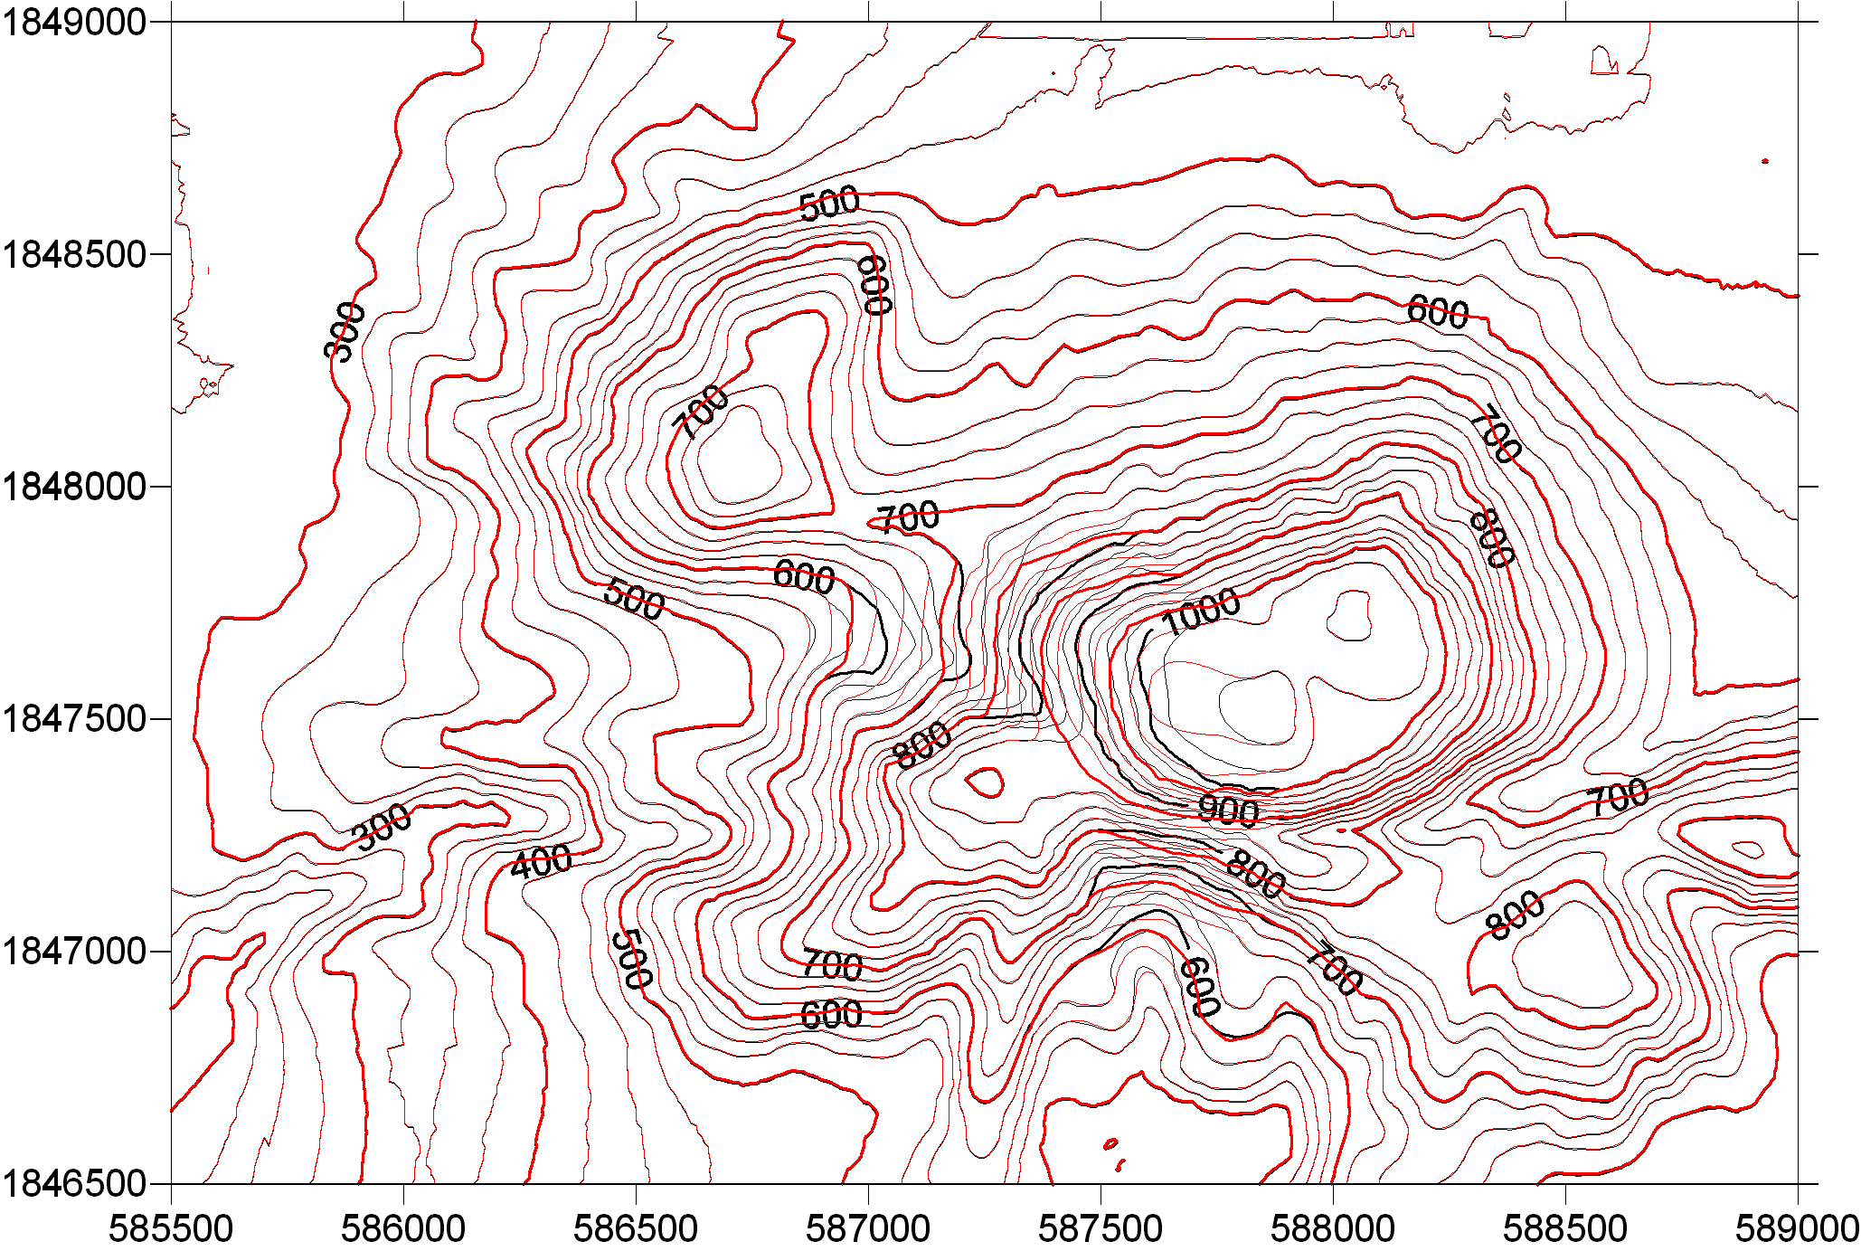

Fig.1 Modification to the AVTIS October 2008 DEM to simulate the growth of the dome in December 2008 -January 2009. Red contours (metres above sea level, every 25 m) are the post-January 2009 surface, black contours the October 2008 surface. Note that this is not intended to represent the pyroclastic flow deposits, which are accounted separately.

